This document shows how to setup the Ansys maxwell model for efficiency map generation using MachineToolKit (MTK). Keep in mind that MTK does simulations and interpolate most of the points within the range of simulations which you did. So its better to double check if the VLL_peaks, Torque, VLL_rms, Irons losses and Magnet losses are correct.
Following are the steps to follow
Step 1:
In the first step, you will go to the model of which you want to generate the efficiency map. Within the model, you chose ACT Extensions. You can also find ACT Extensions in the view tab as well. Now click on the Launch Wizards, there should be Machine Toolkit extension. If you could not find it there, then go to Manage Extensions, find the Machine ToolKit extension, and load it (try to upload it by default, this can be done by clicking on the arrow which is just on the right bottom arrow on the Machine ToolKit icon). Then when you go back to Launch Wizard and you will find it.
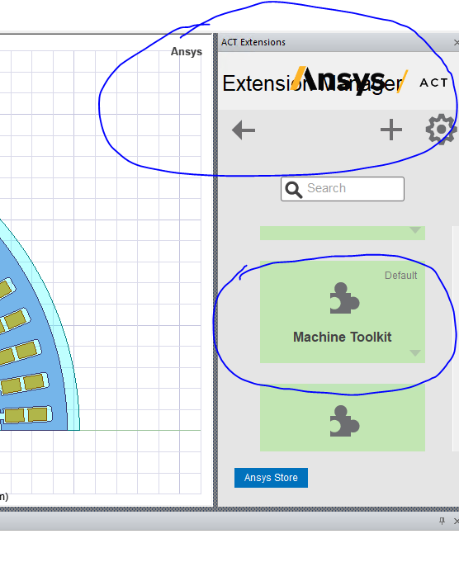
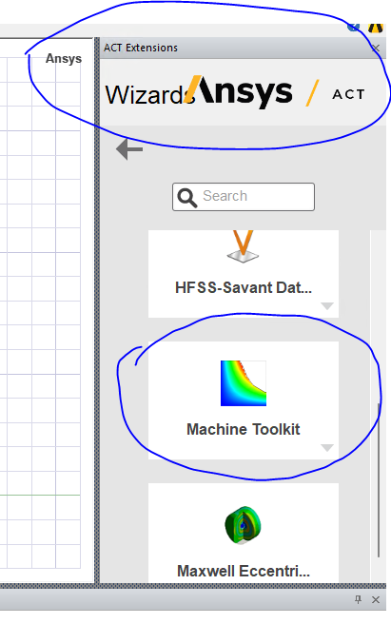

Step 2: Now click on the Machine ToolKit as shown in the picture above. You will see the picture as shown in the picture below.
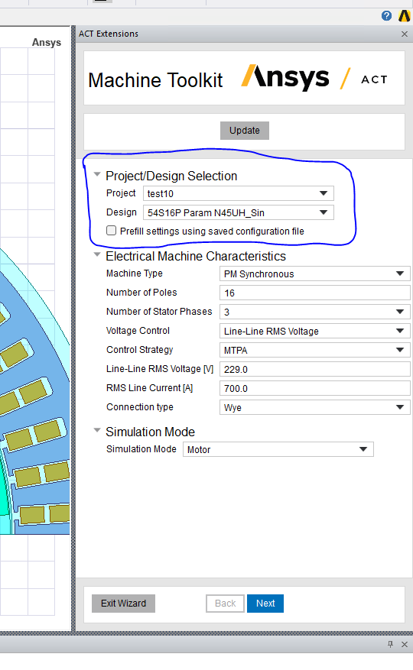
Now let’s go through all the steps which are shown in the picture above.
Project: This is the name of the project (You can put any name, try to keep it short for faster simulations)
Design: This the design name of the project, for which you want to find the efficiency map (again you can put any name, try to keep it short for faster simulations).
Prefill settings using saved configuration file – For the first time, you cannot click it, but when you setup different efficiency maps settings, later you can save these settings. Now if you want to apply those settings to this model, then you can click on this box, it will ask you where the settings are, when you go to those settings, then all the boxes below will be filled with the settings which you put in the previous model which you already made.
Machine type: This is to define the machine type which the Machine ToolKit supports. In our case, if we are using the PM synchronous machine, then we will select the PM Synchronous.
Number of poles: As the name shows, it means the machine pools
Number of Stator Phases: Stator phases, mostly its 3 as usual
Voltage Control: This is how to control the machine based on different methods. We considered Line-Line RMS voltage (very basic one).
Control strategy: This is how to control the motor. Mostly MTPA (Maximum torque per Amps). It is often used. You can choose others based on what you want to achieve.
Line-Line RMS voltage [V]: This is to put the line-to-line RMS voltage that the machine sees. Now how to choose this value? lets assume we have a battery voltage of 360V. Now let’s suppose we have almost 10% drop across the inverter. It means that the coils of the machine will see Vdc = 360*0.9 = 324 V. Now Line-to-Line RMS voltage [V] which the machine see will be 324/sqrt(2) = 229.1 V. [ You can see the basics of how 3 phase machines see the line-to-line voltage].
RMS Line Current [A]: This is the amount of RMS current we put into the motor. This value depends on if you want to consider the continuous or peak torque values. If you want to get the continuous torque values, then you should consider the current values which are close to continuous torque values (means try to put current a bit more above the continuous torque values). If you want to consider the peak torque values, then you have to increase the current, Normally the peak torque or peak current values are 2.5*times the continuous torque or current values. So, if the current is 288 Arms, then the current required will be 280*2.5 = 700 Arms. Here 280 Arms is the current required to get the peak continuous torque values at a certain optimised based speed).
Connection type: Wye or Delta , as the name suggests, it tells you if the machine is star or delta connected.
Simulation Mode: Motor or Generator
Step 2: In this case we will setup the model parameters for simulation purposes, current, advance angle points, Map characteristics.
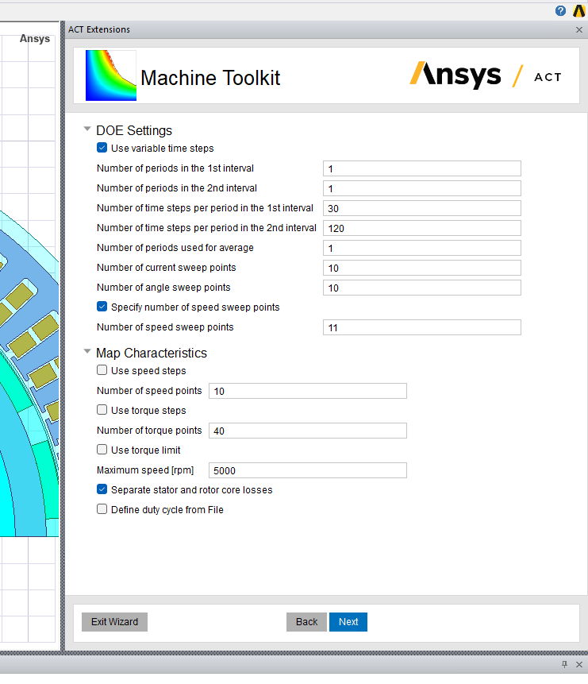
Use variable time steps: Click on this box as it will help in having 2 electrical cycles. This is important as the Iron losses and Magnet losses are settled down in the second cycle.
Number of periods in the 1st interval: keep it as 1. Let make it understand that it means it is the first cycle
Number of periods in the 2nd interval: keep it as 1. This is the 2nd cycle.
Number of time steps per period in the 1st interval: It should be the number of steps in the first interval. It should be around 30 (less than 2nd cycle- the reason is that iron losses are not stable within this interval)
Number of time steps per period in the 2nd interval: It should be the number of steps in the 2nd interval. It should be around 100 to 120 (more than 1st cycle- the reason is that iron losses get stable within this interval).
Number of periods used for average: This is the period to average the losses and torque calculations. Normally the last or in this case the 2nd interval is used to take the average.
Number of current sweep points: This is to go through the number of current (Amps) sweep points. It means it will divide the currents by 11 here. So here the RMS line current is 700 Amps, so it means 700 amps will be divided into 11 different points and the torque values will be found for those points.
Number of angle sweep points: This is to make advance angles which is used to get the reluctance torque or to decrease the Back EMF within the field weakening region.
Click on the Specify number of speed sweet points:
Number of speed sweet points: In this case, we want to find the torque values for different current and angle sweep points. We put 11 in here. So if the peak speed is 5000, and we want in interval of 500, then the number of speed sweet points = 5000/500 = 10 + 1 , the one is coming because we have to include the 0 speed point as well.
Now comes the Map Characteristics
Number of speed points: In this part, after going through all the points which the software calculated based on the current, angle and speed points, it will try to interpolate all the number of speed points values which we want to calculate. Since we want from 500 to 5000 rpm which are 10 points, so we wrote number of speed points = 10
Number of torque points: In this part, after going through all the points which the software calculated based on the current, angle and speed points, it will try to interpolate all the number of torque points values which we want to calculate. In this case, we are using 40 points through which it will try to interpolate the data, you can choose more or less depending on how much data you want and how much clearly you want to understand the machine.
Maximum speed [rpm] = 5000 , as the name suggests, it is the maximum speed of the machine.
Click on the “Separate stator and rotor core losses”

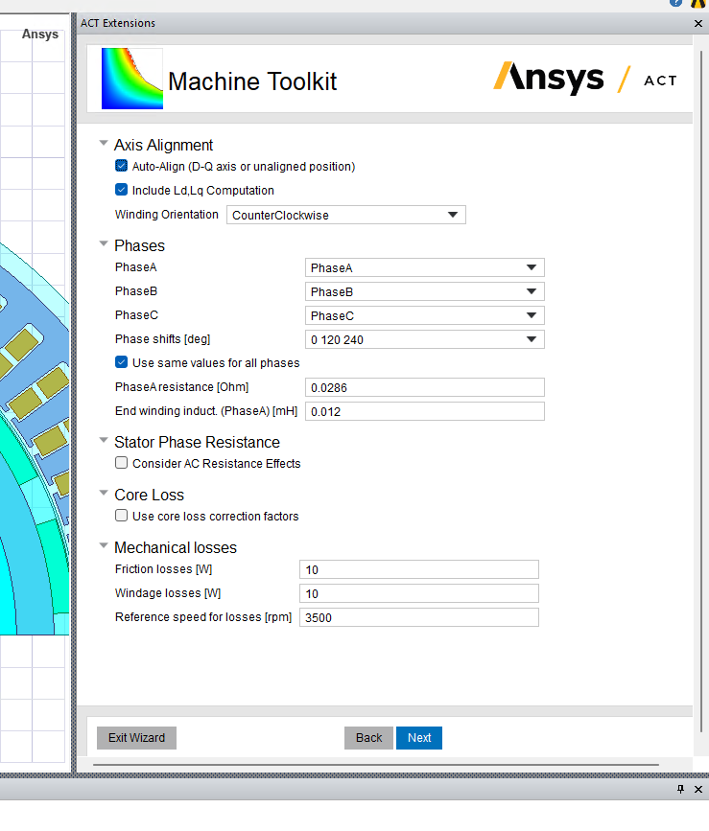
Step 3: In this case, we will arrange the winding orientation, phase arrangement, end inductance, end winding resistance.

Axis Alignment
Click in the Auto Align (D-Q axis or unaligned position) – this is to aligned the D-Q positions of the machine
Click on the include Ld,Lq Computation – this is to find the Ld, Lq values of the machine.
Phases : In this section , we will try to arrange phase A, B and C. Try to arrange phase A,B and C , one after another before putting it to the machine toolkit, this will help in avoiding any mistakes on confusion in the machine toolkit. Otherwise you have to manually arrange the coils to see if phase B is following Phase A or C.
Phase shifts [deg] – 0 120 240 , to show that the phases are 120 degree apart.
Click on Use same values for all phases
PhaseA resistance [Ohm] : This is to include the phase resistance of Phase A. Its normally done to find the copper losses. Its better to have a right calculated value of the phase resistance. The DC copper losses dues to phase resistance may not be accurate (because we don’t know the accurate value of the resistance for different current values as we don’t know the temperature of the motor at that speed and current value).
End winding induct (PhaseA)[mH]: This is to include the end inductance of each phase. How to find this value? Do the following to find out
- First simulate the model in 2D and find the self inductance peak value.
- Second simulate the model in 3D and find the self inductance and find out the peak value.
- Subtract 3D peak inductance – 2D peak inductance value.
Leave Stator Phase resistance and Core loss unclicked
Mechanical Losses:
Friction losses: As the name suggests, it shows friction losses. Keep the value to 10 in this case.
Windage losses: As the name suggests, it shows windage losses. Keep the value to 10 in this case.
Reference speed for losses [rpm]: This is normally the base speed. You can put the base speed of the machine here.

Step 4: In this case, we will try how to simulate and map the data.
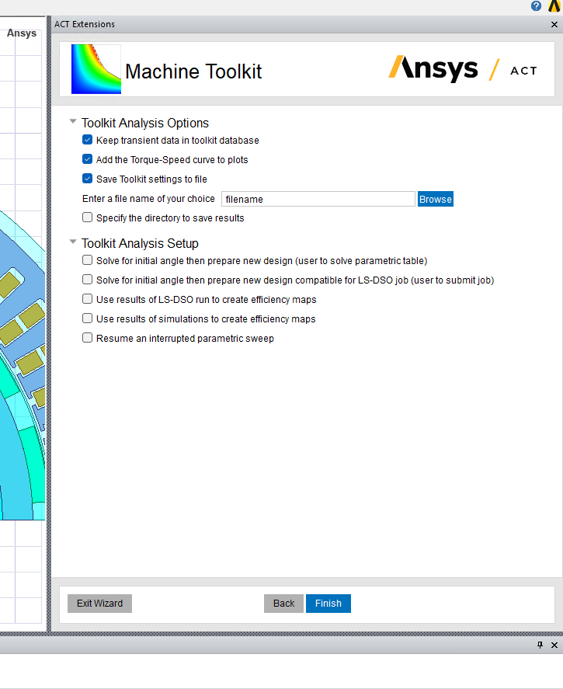

Click on
- Keep transient data toolkit database
- Add torque speed curves to the plots – It add plots to the Results
- Save toolkit setting to file – it is to save the setting of the machine toolkit to a folder or file. So if you refer to it in the future, then you will not need to setup or do the whole things again. See step 2 where we can use this file to prefill settings using saved configuration file
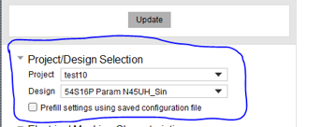

Now in Toolkit Analysis Setup, you can click on either
- Solve for initial angle then prepare new design (user to solve parametric table) – This is the simplest one. It will setup the model for you and then you can double check from the parametric table that the speeds and current values are correct.
- Solve for initial angle then prepare new design compatible for LS-DSO job (use to submit the job) – This method is helpful in making the simulation process quicker and at the end you can get the efficiency maps quickly.

Solve for initial angle then prepare new design compatible for LS-DSO job (use to submit the job)
In this case, we will click on it, then click on Finish. Now the software will go through simulations and try to setup the model by making a new model ending with EffMap1. So we will have the original model and the EffMap1 models as shown in the pic below.
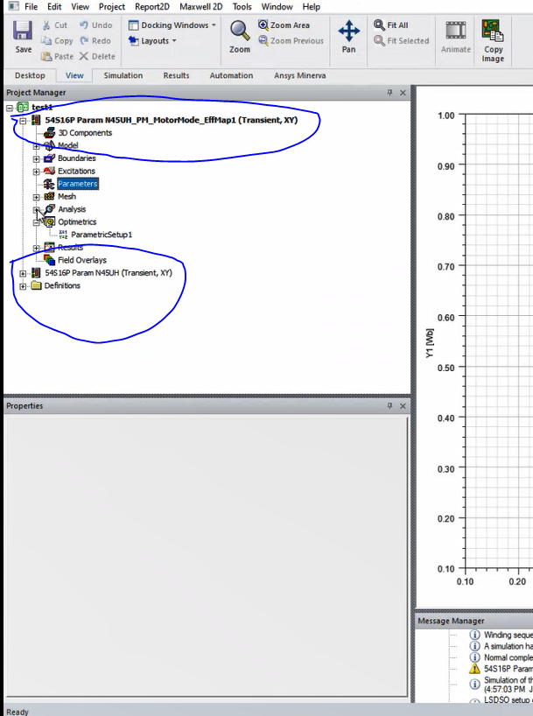
Now double right click on the ParametericSetup1, go to the table and check if the current, speed and Gamma (advance angle) are as according to what you want, If they are not correct then you have to make changes to Step 2 to make it according to what you want.
Now right click on Parametricsetup1 > Submit Job> new window will open. Then here click on (tick) Use large scale DSO.
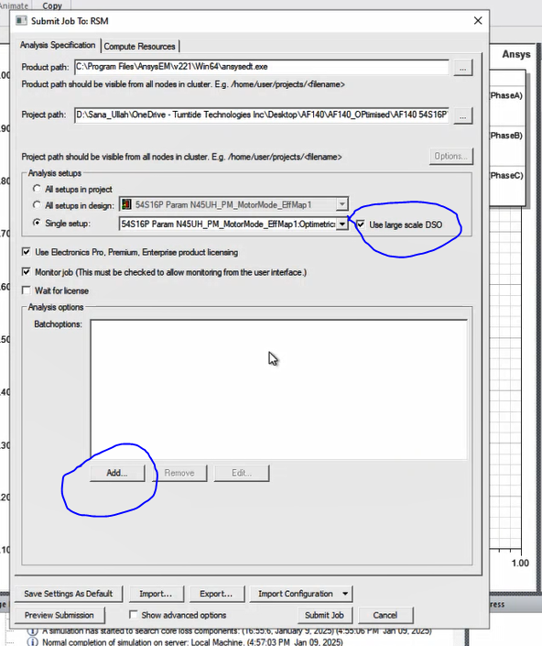
Then click on Add, a new window will open. Here click on the Show registry key Entries (it should be a drop down list) as shown in the picture below. Here select Maxwell 2D.
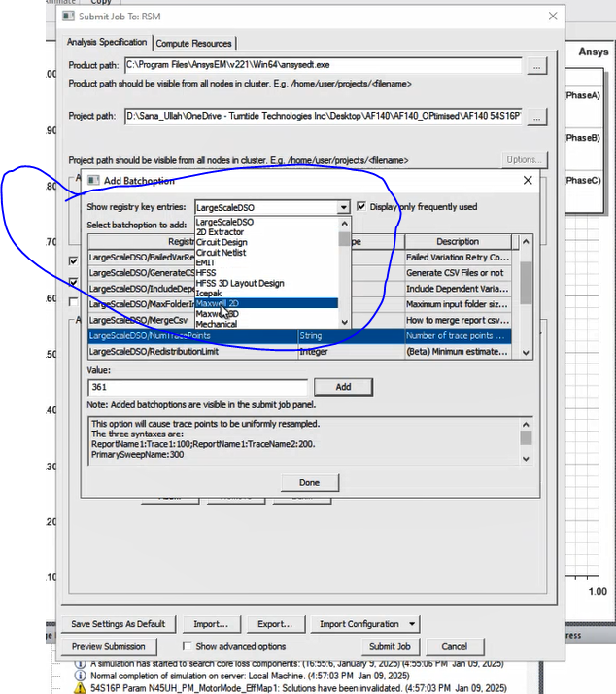
Then after that, click on the following and then click on Add. So the resultant added files will look like as shown in the picture below. Don’t include Large Scale DSO file which are Large Scale DSO/ MergeCsv and Large Scale DSO/ Num Trace Points.
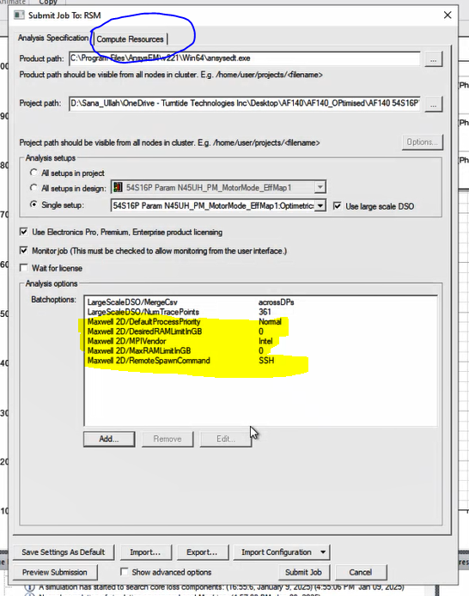
Then click on Compute resources on the top of the same window.
Here select the core number and tasks.
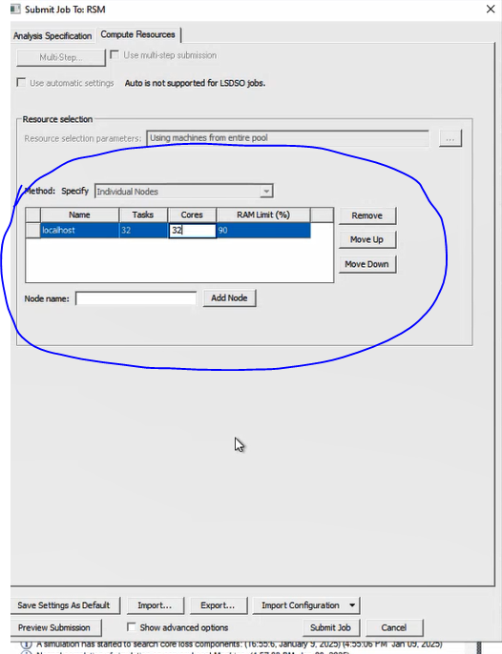
Then click on submit job , it will ask you to close the current design before simulating it. So you can close the current design. Then a new window will open which will say ok to run the model. Try to click on Begin monitoring this job now. It will show you the progress of your work.
